**March 2023**

**Reading for Pleasure**

In March we will be celebrating World Poetry Day (21st March). Below are some poetry books you may enjoy reading.

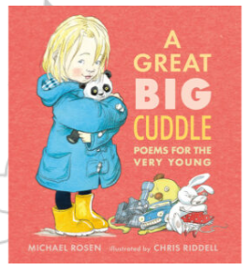**Poetry for 3-5 year olds**

**Poetry for KS1 children**

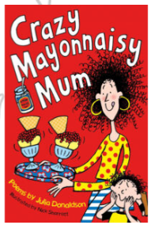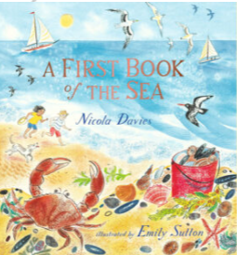

**Poetry for lower KS2 children (7-9 year olds)**

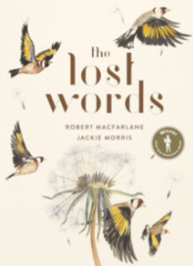

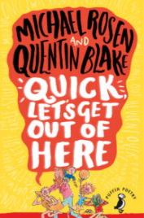**Poetry for upper KS2 children (9-11 year olds)**

